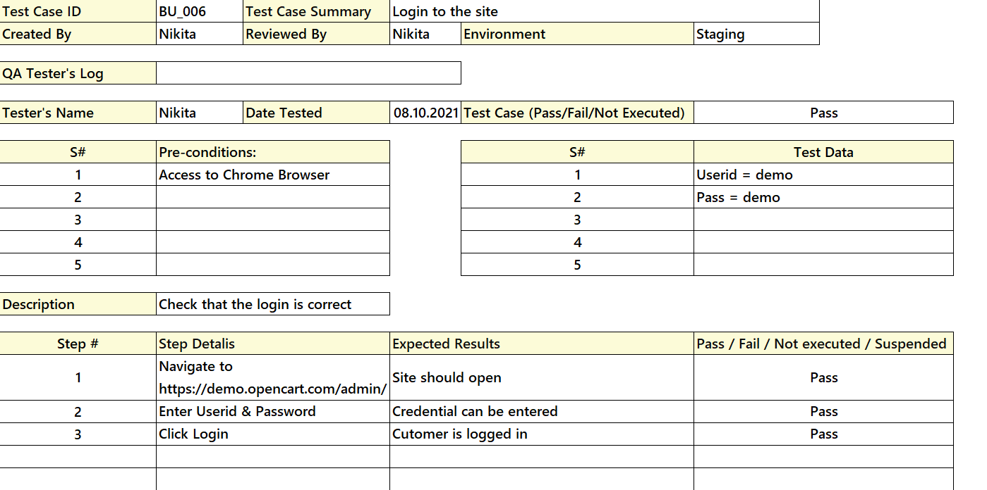

The solution of the decision table technique is applied to the sixth test case. That is, a table is created with all possible variations of the data and the corresponding behavior of the test.

|  |  |  |  |  |  |  |
| --- | --- | --- | --- | --- | --- | --- |
| Condition | Value | Data | | | | |
| Login | Correct  Wrong | Correct | Correct | Correct | Wrong | Wrong |
| Password | Correct  Wrong | Correct | Correct | Wrong | Wrong | Correct |
| Action | Login to the site Authorization failed | Login to the site | Authorization failed | Authorization failed | Authorization failed | Authorization failed |